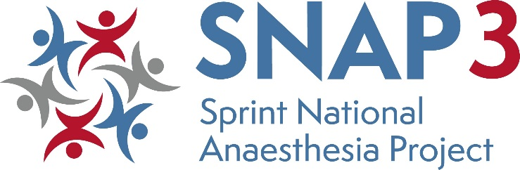

SNAP3 Proposal Form
Your name
Your email address
Mobile number (optional)
Proposed Topic
What is the specific question SNAP3 should answer?
What makes this topic… | Important to patients?  Important to anaesthetists (i.e. practical to study and likely to engage the anaesthetic community)?
Would you be interested in leading SNAP3? | If no: can you suggest a SNAP3 lead?
Is there a specialist society who might collaborate on or
co-fund SNAP3?
If so, have you approached the specialist society regarding your suggestion, and what was their response?
Please outline your suggested methodology to answer the proposed question

Selected proposers of shortlisted topics will be invited to present at the selection meeting on Monday 1st July.

